IdeationPhase Empathize&Discover
Date | 3 Feb 2026
Team ID | LTVIP2026TMIDS60231
Project Name | ToyCraft Tales: Tableau's Vision into Toy  Manufacturer Data
Maximum Marks | 2 Marks
Empathy Map Canvas:
An Empathy Map is a simple visual tool used to better understand the users of a product or service. It captures what a user says, thinks, does, and feels, helping teams view the problem from the user's perspective.
It is especially useful during the empathize phase of a project, where understanding the user's emotions, pain points, and needs is crucial to creating effective and human-centered solutions.
In the context of the ToyCraft Tales project, the empathy map helps us understand toy company managers and analysts. By knowing their frustrations (like handling raw data) and needs (like clear visual dashboards), we can design better Tableau visualizations that truly support their decision-making.
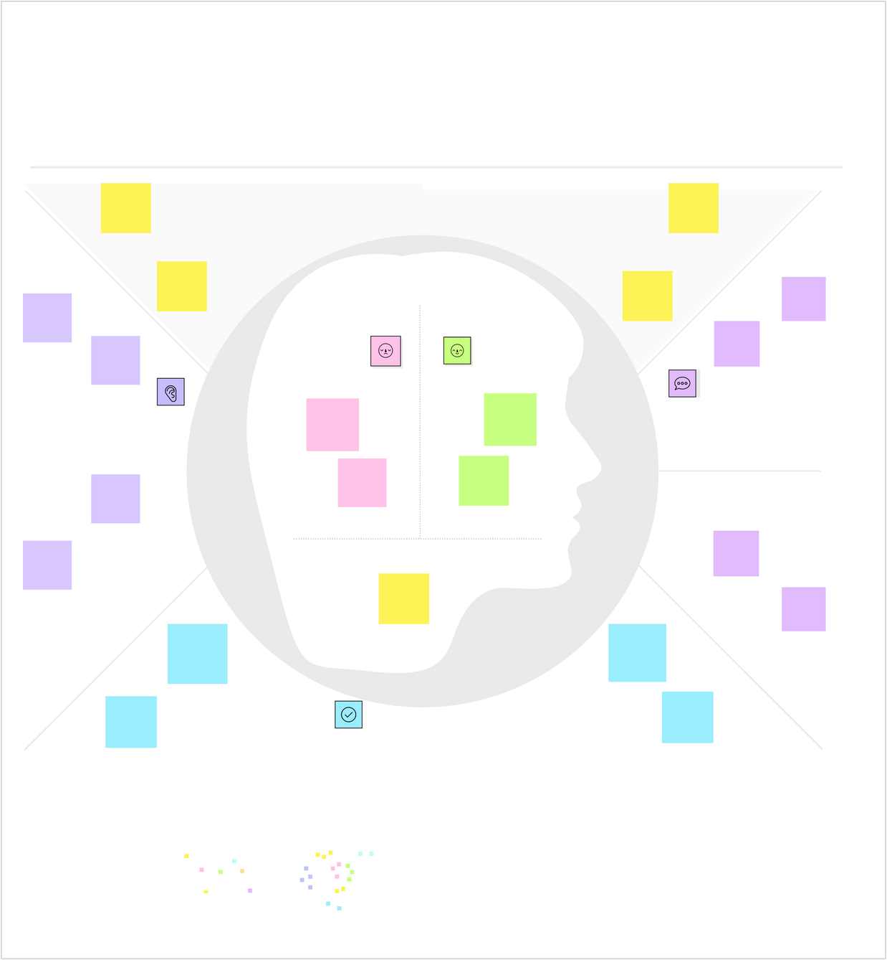
Frustration
with sold
-
out
toys
Joy from
finding a
perfect toy
Tableau
dashboards
highlighting
production
inefficiencies
worry about
quality
.
Can Tableau
help us
predict next
season
’
s hits
?
Kids asking
for trending
toys from
friends
Family
suggesting
popular toy
options
excitement
for new
releases
.
What other thoughts and feelings might influence their behavior
?
W
h
a
t

d
o
e
s

t
h
e
y

H
E
A
R
?
Sales trends
and seasonal
toy demand
spikes
"
Which toys
are selling
best this
season
?"
Analyze
Tableau
dashboards
daily
Store
announcements
about new stock
Store
announcements
about new stock
Adjust
production
schedules
based on data
Customer
feedback on
social media
platform
What does they See
?
w
h
a
t

d
o
e
s

t
h
e
y

S
A
Y

a
n
d

D
o
?
Kids asking
for trending
toys from
friends
Family
suggesting
popular toy
options
Consumers seeking toys for
enjoyment or gifting
Competitor
product
launches
and pricing
Collaborate
with marketing
to launch data
-
driven
campaigns
Industry
experts
discussing
advanced
analytics trends
Industry
experts
discussing
advanced
analytics trends
What does they think and feel
?
Pain
Gain
Example
:
Toy Craft Manufactrerur

